Press Release

REACH Incubator: Next Generation Data Incubator to drive growth in the European startup data sphere

The REACH project, an initiative born out of the successful efforts of EDI – European Data Incubator, and European Commission’s Horizon 2020, aims to accelerate data-driven innovation in Europe, towards the vision of the Common European Data Space and European Data Market.

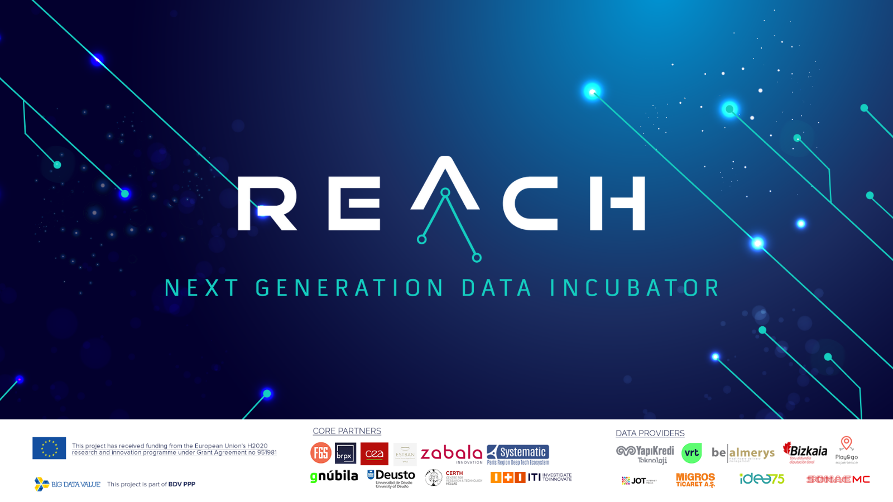

REACH will establish an innovation support mechanism and a multi-stakeholder ecosystem that will facilitate the experimentation of secured and trusted data-fuelled solutions which utilize proprietary, often multi-stakeholder, industrial and personal data. REACH will go beyond EDI, not only by connecting data corporations with European innovators, but also by engaging Digital Innovation Hubs in the conception of high potential data value-chains and value-added services.

REACH is an incubation programme, run by 10 core partners and 9 data providers. The highly versatile and experienced consortium will put to use their knowledge, networks and key assets to facilitate the development of 100+ data-driven business ideas. It will create a fertile ground for startups and SMEs to solve real-life challenges of large corporations, by providing the following benefits:

- Equity Free Funding €120,000
- Access to Large Corporations and their Industrial data sets
- Access to Digital and Business Skills
- REACH toolbox for secure and trusted data value chains
- Big Data Computing Infrastructure
- Access to Private Investment
- Visibility

The programme takes startups through 4 intense stages of technical and business growth (EXPLORE, EXPERIMENT, EVOLVE and EXPOSE) over eleven months, and will go through 3 incubation rounds in its three-and-a-half-year project duration. Due to Covid-19, REACH will take all the precautionary safety measures and implement its incubation services online, whenever on-site meeting and trainings are not allowed.
Juan José Cadavid Gómez, Coordinator of REACH: ”REACH will position itself as the key driver for change in the European Data sphere. We will demonstrate that Data Silos can be broken by enabling a multi-stakeholder cross-sectorial incubator to boost data-fuelled sustainable solutions.”

The first open call was open for three months, from November 2020 to February 2021. The second open call is expected to be launched in November/December 2021. To stay tuned, please follow REACH via its official channels.

Social Media:
https://twitter.com/ReachIncubator
https://www.linkedin.com/company/reach-incubator
https://www.facebook.com/ReachIncubator

Website:
http://www.reach-incubator.eu/

Contact email:
Info@reach-incubator.eu

